Hannover Messe: on route to a 1,000 euro robot with igus
The next generation of the modular joint robotic systems offers flexibility and reduces costs

Reduce costs and improve technology: this is the promise of plastic specialists, igus, and it has now taken a further step in this direction in the field of robotics. At Hannover Messe, the Cologne-based company will exhibit the next generation of robolink D, a direct driven articulated arm made from plastic and aluminium that can be used to build a 4-axis robot from 1,500 euros.

Last year, igus presented its new robolink D product range. In this system, a robolink articulated arm is driven directly by a motor that is attached to the axis. During this process, robolink D uses a lubrication-free igus PRT polymer slewing ring bearing, which is installed in plastic housing. This bearing is now also available as a full polymer version. The bearing is driven by a worm gear drive with the option to add an igus stepper motor Nema 17 or 23. The robolink D joints are available in three sizes and can be combined with components made from plastic or aluminium to form articulated arms with one to four axes. “The modular combination of the robolink articulated arm, the motor and the drive creates a customised and configurable robotic system”, explains Martin Raak, robolink Product Manager. “The construction kit is light and highly flexible. This makes it interesting for not only robot manufacturers and machine and equipment builders but also system integrators and automation specialists from all sectors, from automotive production to medical technology. This particularly applies when dealing with humans-machine interaction.”

Robots from 1,500 euros
Thanks to advances in development and production, it is now possible, depending on the batch size, equipment and load capacity, to use robolink D to develop a 4-axis robot for between 1,500 and 2,500 euros. This includes the motors and the appropriate cables. Both the individual components and the pre-assembled system with construction diagrams can be ordered. The load capacity is up to 4 kg – with a system weight of just 5 to 8 kg. The motors can be controlled using conventional control modules. “In the future, it should also be possible to use a lower cost and simpler motor control involving a web browser, as igus is currently exhibiting at Hannover Messe for the first time for all drylin E linear axes”, comments Raak, offering an insight into how the system is set to develop. This new solution is compatible with many different industrial control systems thanks to CANopen and digital inputs and outputs. “Our aim is to continually develop the robolink D system and thus reduce costs even further so that it becomes possible to construct a 4-axis robot from 1,000 euros in the near future.”

Captions:
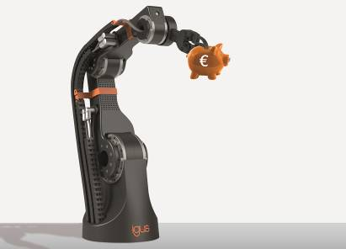

Image PM0915-1
Whether as individual components or a complete system: with the new generation robolink D, a low-cost 4-axis robot can be created from just 1,500 euros. (Source: igus GmbH)

PRESS CONTACT:  Oliver Cyrus  Head of PR and Advertising  igus® GmbH  Spicher Strasse 1a  51147 Cologne  Tel. 0 22 03 / 96 49-459  Fax +49 22 03 / 96 49-631  ocyrus@igus.de  www.igus.de/de/presse | ABOUT IGUS:  igus GmbH is a globally leading manufacturer of energy chain systems and polymer plain bearings. The Cologne-based family business has offices in 36 countries and employs around 2,700 people around the world. In 2014, igus generated a turnover of 469 million euros with motion plastics, plastic components for moving applications. igus operates the largest test laboratories and factories in its sector to offer customers quick turnaround times on innovative products and solutions tailored to their needs.

The terms ‘igus, e-ketten, e-kettensysteme, chainflex, readycable, easychain, e-chain, e-chainsystems, energy chain, energy chain system, flizz, readychain, robolink, pikchain, triflex, twisterchain, invis, drylin, iglidur, igubal, xiros, xirodur, plastics for longer life, CFRIP, dryspin, manus and vector’ are protected by trademark laws in the Federal Republic of Germany and internationally, where applicable.

